ECON300 Final Exam
Note: Total points is 100.

NAME: ____ ___ ID: _________________

I. Multiple Choices (2 pts each, total points is 32)
1) A supply curve shows
A) the quantities sold at different prices.
B) the marginal cost of producing one more unit of a good or service.
C) the marginal benefit from buying one more unit of a good or service.
D) the total cost of producing different quantities of a good or service.

2) At a price of $100, Beachside Canoe Rentals rented 11 canoes. When it increased its rental price to $125, 9 canoes were rented. Calculate the absolute value of the price elasticity of demand for canoe rentals using the midpoint formula.
A) 2
B) 1.25
C) 0.9
D) 0.75

3) In September, buyers of silver expect that the price of silver will rise in October. What happens in the silver market in September, holding all else constant?
A) The quantity demanded decreases.
B) The demand curve shifts to the left.
C) The demand curve shifts to the right.
D) The quantity demanded increases.

4) If the percentage increase in price is 15 percent and the value of the price elasticity of demand is -3, then quantity demanded
A) will increase by 45 percent.
B) will increase by 5 percent.
C) will decrease by 45 percent.
D) will decrease by 5 percent.

5) Bella can produce either a combination of 60 silk roses and 80 silk leaves or a combination of 70 silk roses and 55 silk leaves. If she now produces 60 silk roses and 80 silk leaves, what is the opportunity cost of producing an additional 10 silk roses?
A) 2.5 silk leaves
B) 10 silk leaves
C) 25 silk leaves
D) 55 silk leaves

6) The Great Depression of the 1930s with a large number of workers and factories unemployed would be represented in a production possibilities frontier graph by
A) a point inside the frontier.
B) a point outside the frontier.
C) a point on the frontier.
D) an intercept on either the vertical or the horizontal axis.

7) Which of the following would cause the equilibrium price of ketchup to increase and the equilibrium quantity of ketchup to decrease?
A) a decrease in the price of tomatoes
B) an increase in the price of tomatoes
C) an increase in the price of mustard, a substitute for ketchup
D) an increase in the price of french fries, a complement for ketchup

8) Ranchers can raise either cattle or sheep on their land. Which of the following would cause the supply of sheep to increase?
A) an increase in the price of sheep
B) a decrease in the price of cattle
C) an increase in the demand for cattle
D) an increase in the price of sheep feed

9) If the price elasticity of demand for insulin is equal to zero then the demand curve for insulin is
A) horizontal.
B) downward sloping.
C) curvilinear.
D) vertical.

10) If the slope of a demand curve is equal to -0.1 then
A) demand is inelastic.
B) we don't know whether the demand is elastic or inelastic.
C) the demand is elastic at low prices and inelastic at high prices.
D) as price increases by 10 percent quantity demanded decreases by 1 percent.

11) If another worker adds 9 units of output to a group of workers who had an average product of 7 units, then the average product of labor
A) will remain the same.
B) will increase.
C) will decrease.
D) and what will happen to it cannot be determined.

12) If the total cost of producing 20 units of output is $1,000 and the average variable cost is $35, what is the firm's average fixed cost at that level of output?
A) $65
B) $50
C) $15
D) It is impossible to determine without additional information.

13) Assume that price is greater than average variable cost. If a perfectly competitive seller is producing at an output where price is $11 and the marginal cost is $14.54, then to maximize profits the firm should
A) continue producing at the current output.
B) produce a larger level of output.
C) produce a smaller level of output.
D) There is not enough information given to answer the question.

14) Which of the following statements applies to a monopolist but not to a perfectly competitive firm at their profit maximizing outputs?
A) Marginal revenue is less than price.
B) Marginal revenue equals marginal cost.
C) Price equals marginal cost.
D) Average revenue equals average cost.

15) The Bureau of Labor Statistics would categorize a person as ________ if they were temporarily away from their job because they were ill.
A) employed
B) unemployed
C) a discouraged worker
D) out of the labor force

16) Suppose in 2014, you purchase a house built in 2003. Which of the following would be included in the gross domestic product for 2014?
A) the value of the house in 2014
B) the value of the house in 2003
C) the value of the house in 2014 minus depreciation
D) the value of the services of the real estate agent

II. Essays
1. Table 1-2

Extra Hours Open | Total Revenue (dollars) | MC | MB
1 | $25 | 16 | 25
2 | 45 | 16 | 20
3 | 70 | 16 | 25
4 | 90 | 16 | 20
5 | 105 | 16 | 15
6 | 100 | 16 | -5

Thuy Anh runs a small flower shop in the town of Florabunda. She is debating whether she should extend her hours of operation. Thuy Anh figures that her sales revenue will depend on the number of extra hours the flower shop is open as shown in the table above. She would have to hire a worker for those extra hours at a wage rate of $16 per hour. (3 pts each, 9 pts total)

1) Refer to Table 1-2. Using marginal analysis, by how many hours should Thuy Anh extend her flower shop's hours of operations?

- 4 hours
2) Refer to Table 1-2. What is Thuy Anh's marginal benefit if she decides to stay open for three hours instead of two hours?
- $25

3) Refer to Table 1-2. What is Thuy Anh's marginal cost if she decides to stay open for three hours instead of two hours?

- $16
2. Table 2-30

 | Wristwatch | Rice (bushels)
Japan | 200 hours | 10 hours
Thailand | 180 hours | 6 hours

Refer to Table 2-30. This table shows the number of labor hours required to produce a wristwatch and a bushel of rice in Japan and Thailand. (3 pts each, 15 pts total)

1) Which country has an absolute advantage in the production of wristwatches?
- Thailand
2) What is Japan's opportunity cost of producing one wristwatch?
- 20 bushels of rice
3) What is Thailand's opportunity cost of producing one wristwatch?
- 30 bushels of rice
4) What is Thailand's opportunity cost of producing one bushel of rice?
- 1/30 = 0.03 wristwatch
5) If each country specializes in the production of the product in which it has a comparative advantage, who should produce wristwatches?
- Japan

3. The graph below represents the market for lychee nuts. The equilibrium price is $7.00 per bushel, but the market price is $5.00 per bushel.

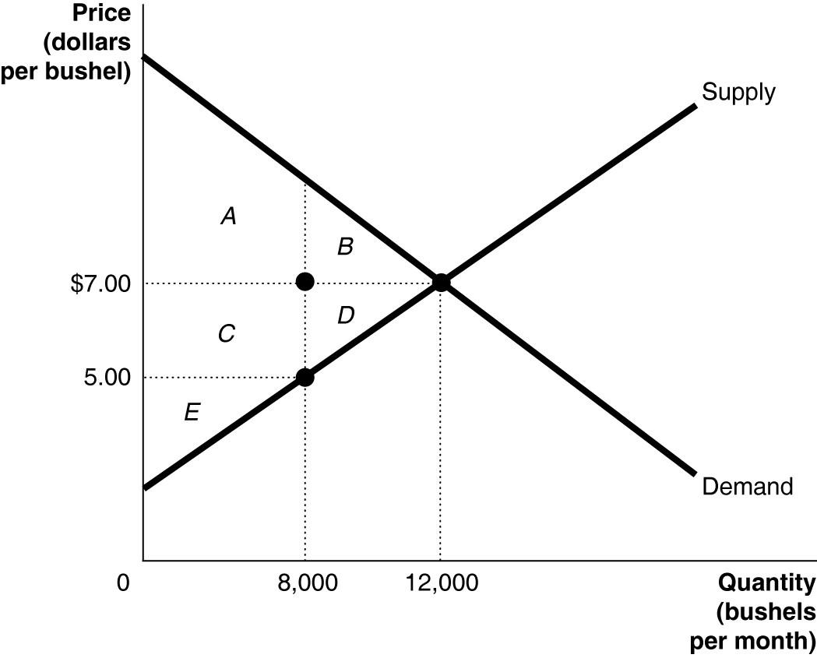
1) Identify the areas representing consumer surplus (CS), producer surplus (PS), and deadweight loss at the market price of $5.00. (6 pts)
- The areas representing consumer surplus is A+C. The areas representing producer surplus is E. The areas representing deadweight loss is B+D

2) Identify the areas representing consumer surplus (CS), producer surplus (PS), and deadweight loss at the equilibrium price of $7.00. (6 pts)
- The areas representing consumer surplus is A+B. The areas representing producer surplus is C+D+E. There is no deadweight loss

4. Table 7-1
Quantity of Pita Wraps | Total Utility | Quantity of Bubble Tea | Total Utility | MUw | MUt | MUw/Pw | MUt/Pt
1 | 60 | 1 | 40 | 60 | 40 | 10 | 40/3
2 | 102 | 2 | 70 | 42 | 30 | 7 | 10
3 | 132 | 3 | 91 | 30 | 21 | 5 | 7
4 | 144 | 4 | 106 | 12 | 15 | 2 | 5
5 | 144 | 5 | 112 | 0 | 6 | 0 | 2
6 | 138 | 6 | 115 | -6 | 3 | -1 | 1
7 | 128 | 7 | 115 | -10 | 0 | -10/6 | 0
The price of a Pita Wrap is $6 and the price of a glass of Bubble Tea is $3. Table 7-1 shows his total utility from different quantities of the two items. (3 pts each, 6 pts total)

1). Refer to Table 7-1. Without budget constraint, can you list out two potential optimal consumption bundles for Keegan?

- 2 Pita Wrap and 3 glass of Bubble Tea
- 3 Pita Wrap and 4 glass of Bubble Tea

2) Refer to Table 7-1. Keegan has $30 to spend on Pita Wraps and Bubble Tea. What is Keegan's optimal consumption bundle?
- 3 Pita Wrap and 4 glass of Bubble Tea

5.Figure 10-6
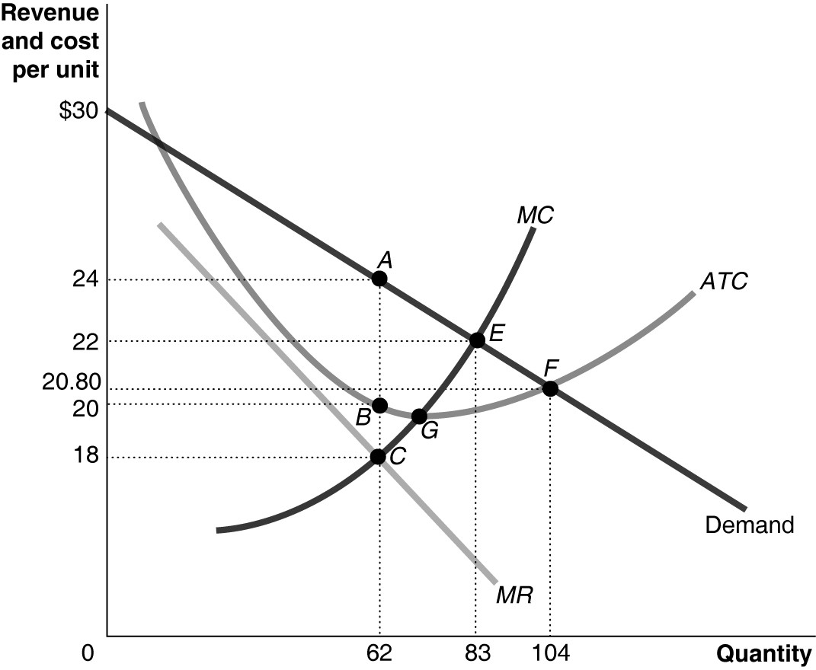
Figure 10-6 shows the cost and demand curves for a monopolist. (3 pts each, 12 pts total)

1) Refer to Figure 10-6. The profit-maximizing output and price for the monopolist are

- Output = 62, price = $24

2) Refer to Figure 10-6. The monopolist's total revenue is
- $1488

3) Refer to Figure 10-6. The monopolist's total cost is
- $1240

4) Refer to Figure 10-6. The monopolist earns a profit of
- $248

6.Table 12-3
Consumption expenditures | $800
Investment expenditures | 200
Government purchases | 300
Exports | 100
Imports | 200
Wages | 800
Refer to Table 12-3. Consider the data above (in billions of dollars) for an economy: How much is the Gross domestic product (in billions of dollars) for this economy? (3 pts)

- GDP = 800 + 200 + 300 + (100 – 200) = $1200 (in billions of dollars)

7.Table 12-13
Year | Oranges Produced | Price of Oranges | Shirts Produced | Price of Shirts
2009 | 1,800 | $0.90 | 110 | $30.00
2011 | 2,000 | 1.00 | 110 | 35.00
Consider the data shown above for Vicuna, a country that produces only two products: oranges and shirts.(3 pts each, 6 pts total)
1) Refer to Table 12-13. What is Real GDP for Vicuna for 2009 using 2011 as the base year?

- Real GDP 2009 = 1800*1 + 110*35 = $5650

2) Refer to Table 12-13. What is Nominal GDP for Vicuna for 2009?

- Nominal GDP 2009 = 1800*0.9 + 110*30 = $4920

8. Table 13-2
Base Year (2006) 2013
Product | Quantity | Price | Price
Milk | 50 | $1.20 | $1.50
Bread | 100 | 1.00 | 1.10
Refer to Table 13-2. Assume the market basket for the consumer price index has two products — bread and milk — with the following values in 2006 and 2013 for price and quantity: (5 pts total)
1) What is the Consumer Price Index for 2013? (2 pts)
- Consumer Price Index for 2013 is [(50*1.5 + 100*1.1)/ (50*1.2 + 100*1)] * 100 = 115.625
2) What is the inflation rate from 2006 to 2013? (3 pts)
- The inflation rate from 2006 to 2013 is [(185-160)/160] * 100 = 15.625 %

